SUPPLEMENTARY MATERIAL
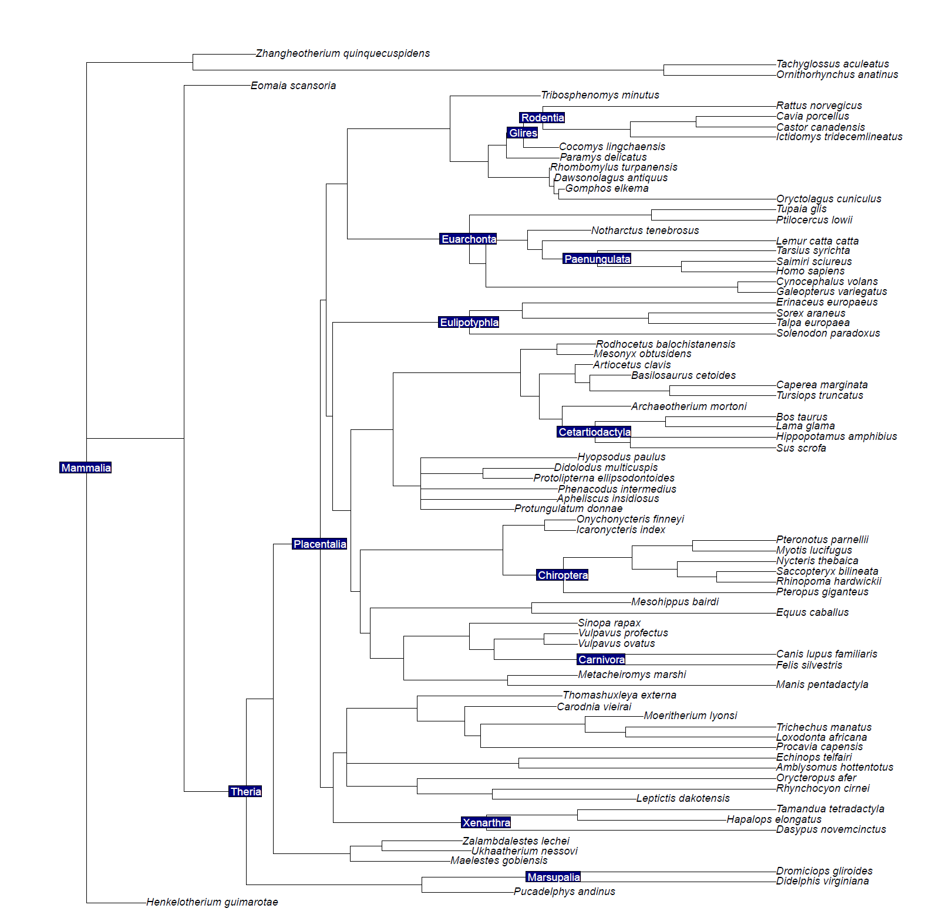
Supplementary Figure S1. Location of the node constraints on the node-dated phylogeny.

 | Minimum | Maximum
Mammalia | 162.9 | 191.1
Theria | 124 | 171.2
Marsupalia | 48.6 | 131.3 (Benton et al. 2015)
Placentalia | 61.6 (Benton et al. 2015) | 131.5
Paengulata | 55.6 | 164.6 (Benton et al.)
Xenarthra | 55.6 | 164.6 (Benton et al.)
Carnivora | 39.68 | 65.8
Chiroptera | 48.6 | 65.8
Cetartiodactyla | 52.4 | 65.8
Eulipotyphla | 61.5 | 164.6 (Benton et al.)
Euarchonta | 61.5 | 164.6 (Benton et al.)
Glires | 61.5 | 164.6 (Benton et al.)
Rodentia | 55.6 | 65.8
Primates | 55.6 | 65.8

Supplementary Table S1. Use of node constraints when additional node dating was employed alongside tip dating. Unless stated the dates used in analyses come from dos Reis et al. (2012), with the additional dates from Benton et al. (2015).

 | Uniform Prior | Uniform Prior
Mammalia | 167.6 (162.9,178) | 177.1 (162.9,190.4)
Marsupalia | 49.4 (26.9,74.7) | 52.7 (23.3,84.8)
Placentals | 147 (135.5,158.6) | 166.6 (147.7,186.3)
Boreoeutheria | 145.5 (134.2,157.5) | 162.9 (143.3,183.2)
Atlantogenata | 143.6 (130.5,155.9) | 161.5 (140.3,182.1)
Afrotheria | 139.9 (125.8,153.1) | 153.6 (129.8,176.3)
Xenarthra | 77.7 (51.7,105.6) | 101.2 (63.2,139.2)
Euarchontoglires | 140.5 (125.7,153.8) | 153.6 (130.1,176.6)
Laurasiatheria | 144 (132.3,155.7) | 160 (139.9,180.6)
Euarchonta | 100.7 (85.4,117.2) | 97.3 (66.8,128.7)
Glires | 97.3 (77.1,119.4) | 106.2 (78.6,136.7)
Eulipotyphla | 107 (82.4,131.1) | 119.6 (87.8,151.7)
Carnivora | 34.9 (17.4,54.3) | 40.4 (16.9,68.1)
Certartiodactyla | 100.2 (84.5,115.9) | 108.7 (81.7,137.3)
Chiroptera | 89 (71.2,109.4) | 80.4 (52.6,111.5)
Rodentia | 56.5 (40,73.9) | 72 (44.5,101)
Paenungulata | 116.5 (97.7,135) | 116.9 (86.2,148.2)
Cow/Horse | 138.8 (126.1,150.8) | 148.6 (125.8,171.5)
Pig/Cow | 97.2 (81.7,113.2) | 101.7 (75.3,130.1)
Dolphin/Cow | 95.2 (79.6,110.9) | 95.5 (69.6,124.1)
Horse/Cat/Bat | 135.9 (122.5,148.7) | 144 (119.9,167.2)
Horse/Cat | 133.3 (119.3,146.8) | 138.9 (113.8,163.6)
Human/Tarsier | 46.9 (31.3,65) | 54.8 (32.5,80.1)

Supplementary Table S2. Morphological clock ages indicate an ancient origin for Placentalia when using a uniform distribution on the root constraint.

 | Sixty Percent | Seventy Percent | Eighty Percent | Ninety Percent
Mammalia | 165.2 (162.9,173.1) | 170.5 (162.9,185.8) | 170.3 (162.9,185.8) | 171.9 (162.9,191.9)
Marsupials | 51.9 (23.4,81.1) | 56.1 (29.4,86.1) | 56.1 (24.9,86.2) | 48.1 (9.2,95.8)
Placentals | 145.2 (125.9,163.4) | 157.5 (138.1,176.7) | 155.2 (137.8,174.9) | 165.3 (149.8,187.5)
Boreoeutheria | 142.5 (123.2,160.9) | 154.9 (135.9,174.1) | 151.9 (134.4,172) | 162.6 (146.2,184.5)
Atlantogenata | 140.3 (119.7,159.5) | 153.4 (133.6,173.5) | 151.3 (133.1,171.6) | 160.3 (140.2,183.5)
Afrotheria | 111 (81.8,138.5) | 148.4 (127.9,169.4) | 146.4 (126.1,167.3) | 153.4 (129.2,178.9)
Xenarthra | 91 (59.6,124.8) | 99.4 (68,131.5) | 109.5 (74.9,143.5) | 139.9 (90.2,174.6)
Euarchontoglires | 134.9 (112.1,154.3) | 147.9 (126.1,168.7) | 143.4 (121.3,166.2) | 155 (131.2,179.8)
Laurasiatheria | 139.9 (120.5,158.3) | 152.2 (133.9,172.1) | 149 (131.2,169) | 159.4 (141.8,181.4)
Euarchonta | 84.7 (66.9,105.9) | 100.8 (83.7,121.5) | 95.6 (77.8,116.2) | 110.3 (84,140.2)
Eulipotyphla | 95.1 (69.2,123.5) | 102 (78.3,128.9) | 106.1 (79.4,135.6) | 130.2 (93,163.6)
Carnivora | 97.2 (63.9,130.7) | 110.7 (79.9,140.8) | 117.2 (84,149.8) | 106.4 (61.8,155.8)
Certartiodactyla | 34.9 (12,59.1) | 39.1 (17.2,65.2) | 39.7 (15.4,67.6) | 40.4 (5.3,81)
Chiroptera | 55.5 (31.6,81.5) | 75.2 (53.7,99.6) | 80 (54.8,106.2) | 82 (40.5,123.3)
Rodentia | 66.2 (45.6,88.7) | 70.5 (49,92.6) | 65.3 (42.3,91.8) | 65.2 (35.8,102.9)
Paenungulata | 52.2 (34.7,69.3) | 53.2 (34.9,72.1) | 50.6 (30.7,69.9) | 58.2 (27.7,94.1)
CowHorse | 87 (57.9,118.7) | 106.7 (80.4,134.6) | 109.9 (81.4,137.5) | 96.7 (60.2,134.9)
PigCow | 132 (112,152) | 145.4 (126.3,165.9) | 142.5 (123.9,161.8) | 153 (132.7,174.9)
DolphinCow | 55.5 (31.6,81.5) | 75.2 (53.7,99.6) | 80 (54.8,106.2) | 82 (40.5,123.3)
HorseCatBat | 72.9 (43.2,102.2) | 101.7 (79.9,126) | 115.6 (93.5,137.3) | 138.6 (111.8,165)
HorseCat | 128.6 (108.2,147.7) | 140.8 (121.3,161.5) | 137.9 (118.2,157.5) | 140.5 (114.7,166)
HumanTarsier | 125.2 (105.8,145.7) | 136.7 (116.9,158.5) | 132.2 (112.4,153.2) | 132.8 (105.6,159.2)

Supplementary Table S3. Identical constrained, non-fixed topologies, results in ages that are much older than when node-calibration is used.

 | Sixty Percent | Seventy Percent | Eighty Percent | Ninety Percent
Mammalia | 167.6 (162.9,179.7) | 170.7 (162.9,187.8) | 173 (162.9,191) | 171.1 (162.9,189.7)
Marsupials | 53.9 (48.6,67.3) | 54.2 (48.6,68.1) | 54.4 (48.6,69) | 55.5 (48.6,75.4)
Placentals | 110.8 (97.6,124) | 120.1 (107.1,133.6) | 112.6 (101.7,124.8) | 108.8 (91.2,126)
Boreoeutheria | 109.3 (96.1,122.5) | 118.5 (105.8,132) | 110.7 (99.7,122.4) | 106.9 (89.3,123)
Atlantogenata | 107.7 (93.6,120.8) | 117.3 (104.1,131.6) | 110 (98.1,122.6) | 105.2 (87.7,122.7)
Afrotheria | 104.4 (90.2,118.4) | 113.9 (99.9,128.5) | 106.9 (94.2,120.1) | 100.8 (83.5,119.1)
Xenarthra | 70.3 (55.6,88) | 73.4 (55.6,93) | 77.3 (55.7,97.5) | 86.4 (57.3,109.5)
Euarchontoglires | 104.2 (89.9,118) | 113.5 (99.3,127.9) | 105.2 (92.3,118.4) | 100.7 (83.6,118.4)
Laurasiatheria | 107.8 (93.8,120.3) | 116.8 (104.2,130.1) | 108.8 (97.9,120.7) | 104.5 (87.8,120.6)
Euarchonta | 74.6 (61.9,88.3) | 78.5 (64.5,94.1) | 78.6 (64.5,93.7) | 80.8 (63,99.5)
Eulipotyphla | 74.5 (61.5,92.8) | 80.9 (61.7,99.4) | 82.9 (62,101.7) | 73.2 (61.5,93)
Carnivora | 42.3 (39.7,49.9) | 42.4 (39.7,50.4) | 42.5 (39.7,50.4) | 43.2 (39.7,53.5)
Certartiodactyla | 44 (30,58.7) | 50.2 (33.7,66.2) | 50.3 (32.3,67.1) | 38.7 (19.6,62.6)
Chiroptera | 51.7 (48.7,59.8) | 51.9 (48.7,59.9) | 51 (48.7,57.8) | 50.7 (48.7,57.1)
Rodentia | 56.6 (55.6,59.7) | 56.9 (55.6,60.7) | 56.7 (55.6,60.1) | 57.1 (55.6,61.9)
Paenungulata | 71.7 (55.6,87.7) | 81.8 (63.8,100.9) | 80.3 (61,98.4) | 65.5 (55.6,83.6)
CowHorse | 103.3 (89.5,115.9) | 112.8 (99.9,125.7) | 104.6 (93.4,116.5) | 99.4 (84.2,115.1)
PigCow | 44 (30,58.7) | 50.2 (33.7,66.2) | 50.3 (32.3,67.1) | 38.7 (19.6,62.6)
DolphinCow | 57.5 (52.4,69.9) | 67.5 (53.5,82.3) | 72.4 (58.3,86.8) | 67.6 (52.4,84.4)
HorseCatBat | 101.1 (87.7,113.9) | 109.5 (96.6,122.9) | 102 (90.4,113.9) | 92.6 (77,108.1)
HorseCat | 98.6 (85.1,111.6) | 106.8 (93.8,120.6) | 98.6 (86.4,111.2) | 88.5 (73.8,104.6)
HumanTarsier | 43.3 (28.8,55.9) | 44.8 (31.2,56.7) | 39.9 (25.3,53.7) | 43.1 (23.7,58)

Supplementary Table 4. Use of 13 internal node estimates, alongside the use of tip dating, results in node estimates that are younger than the use of tip dating alone.

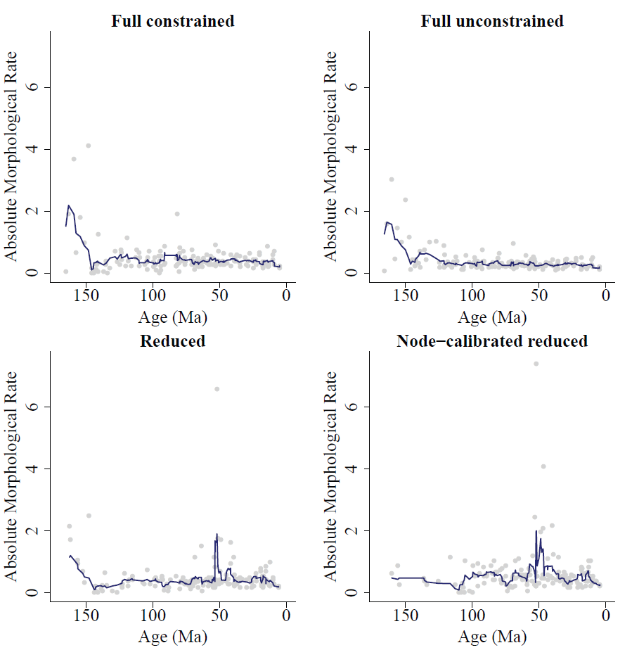
Supplementary Figure 2. Absolute morphological rates through time, plotted at the mid-point of branches, following the protocol of Beck and Lee (2014). There is a tendency for high rates to be found at the root in the constrained and unconstrained fixed tree (Full constrained and Full Unconstrained), but these effects are not as prominent in the reduced datasets (with 60% of the most incomplete characters removed), especially when nodes are calibrated to time (Node-calibrated reduced).

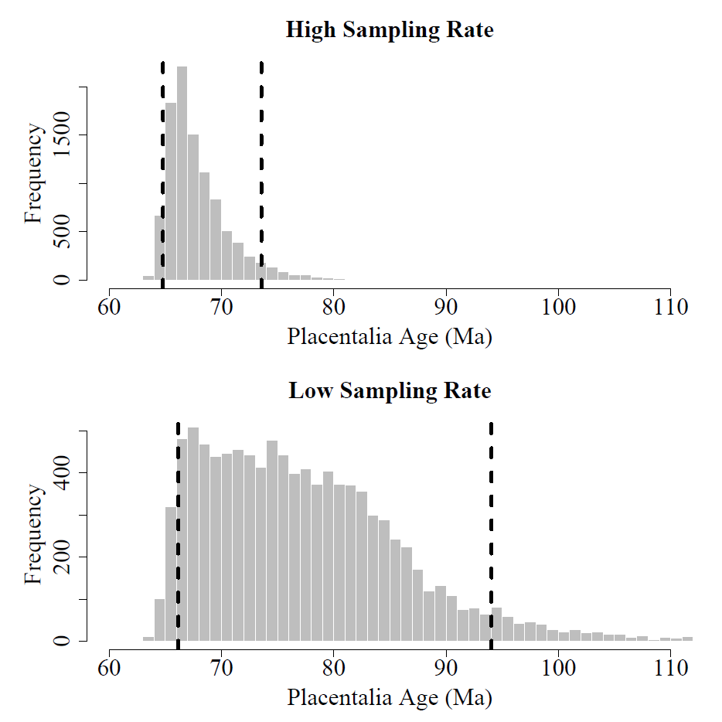
Supplementary Figure S3. Estimated ages of Placentalia from Cal3 (Bapst 2013) are younger than morphological clock approaches, but are dependent upon assumed sampling rates. Age estimates of placentals are significantly younger than any of the morphological clock approaches when speciation, extinction, and sampling rates are considered (using the R package paleotree). Even when sampling rates are input at very low rates (0.003 per-lineage-per Myr), the 95% confidence interval of the age is 106 Ma; an age that is younger than the morphological clock analysed here.

